**Implementation of Augmented Reality for Traditional Toys**

Ahmad Zaini

Computer Science Department, School of Computer Science

Bina Nusantara University

Malang, Indonesia 65154

[Ahmad.zaini@binus.ac.id](mailto:Ahmad.zaini@binus.ac.id)

Dimas Syauqi Syafa

Computer Science Department, School of Computer Science

Bina Nusantara University

Malang, Indonesia 65154

[dimas.syafa@binus.ac.id](mailto:dimas.syafa@binus.ac.id)

Gracio Elika Enold T.

Computer Science Department, School of Computer Science

Bina Nusantara University

Malang, Indonesia 65154

[gracio.tirtahardja@binus.ac.id](mailto:gracio.tirtahardja@binus.ac.id)

1. **INTRODUCTION**

Traditional games are games that emerged due to the influence of children's lives in a rural area. However, in today's modern era, traditional games have begun to be abandoned because they are considered ancient and outdated. The application of Augmented Reality (AR) to traditional games is a good start to re-start a faded culture.

Augmented Reality (AR) itself is a technology where two-dimensional and three-dimensional objects can be inserted into a three-dimensional virtual world, then these two and three-dimensional objects can be projected into virtual objects which at the same time must be done in real time.

1. **LITERATURE REVIEW**

Use Case

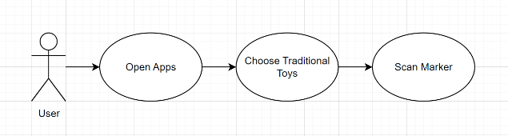

1. **METHODS**

The method used in the search is concept design, application design design, search and collection of materials used in making applications, application development, application testing, and finally distribution.

### System Overview

The application uses Augmanted Reality to display traditional toy objects on the poster image to be scanned. The application can be accessed via Android mobile, and for posters as target to be scanned, it can be opened via the dolanan website.

### System Implementation

How to Access the app:

1. Download the app to your Android mobile device.
2. Make sure that the device supports the system for augmented reality.
3. Open the downloaded application on the mobile device.
4. Press mulai to enter the application menu.
5. Select the object image you want to display according to the image.

### Tools and Technology

Making this mobile application using Unity (David Helgason, 2004) Engine software as a place to create applications and Vuforia to store image targets that will be scanned by the camera. The initial design and concept of the application was made using figma (Dylan Field dan Evan Wallace, 2012).

In this application using technology in the form of Augmented Reality which implements real objects into digital objects which are then displayed back into the real world using a camera.

### Things to Improve

This application has not included many objects, it is hoped that in the future it will add objects and make the application more interactive with a more attractive appearance.

1. **RESULT**
   1. Main Menu

1. **DISCUSSION**
2. **CONCLUSION**
3. **ACKNOWLEDGEMENTS**

Thank you to Bina Nusantara University as well as to the supervising lecturer Mr. Fairuz Iqbal Maulana, S.T., M.T. as a multimedia systems lecturer who has provided the opportunity to make a project in the form of this mobile application which adds to our insight and knowledge in application makers

1. **REFERENCES**